**Question 1 .Create a virtual network with 2 subnets. Each subnet should have 16 Ips only.**

**Solution:**

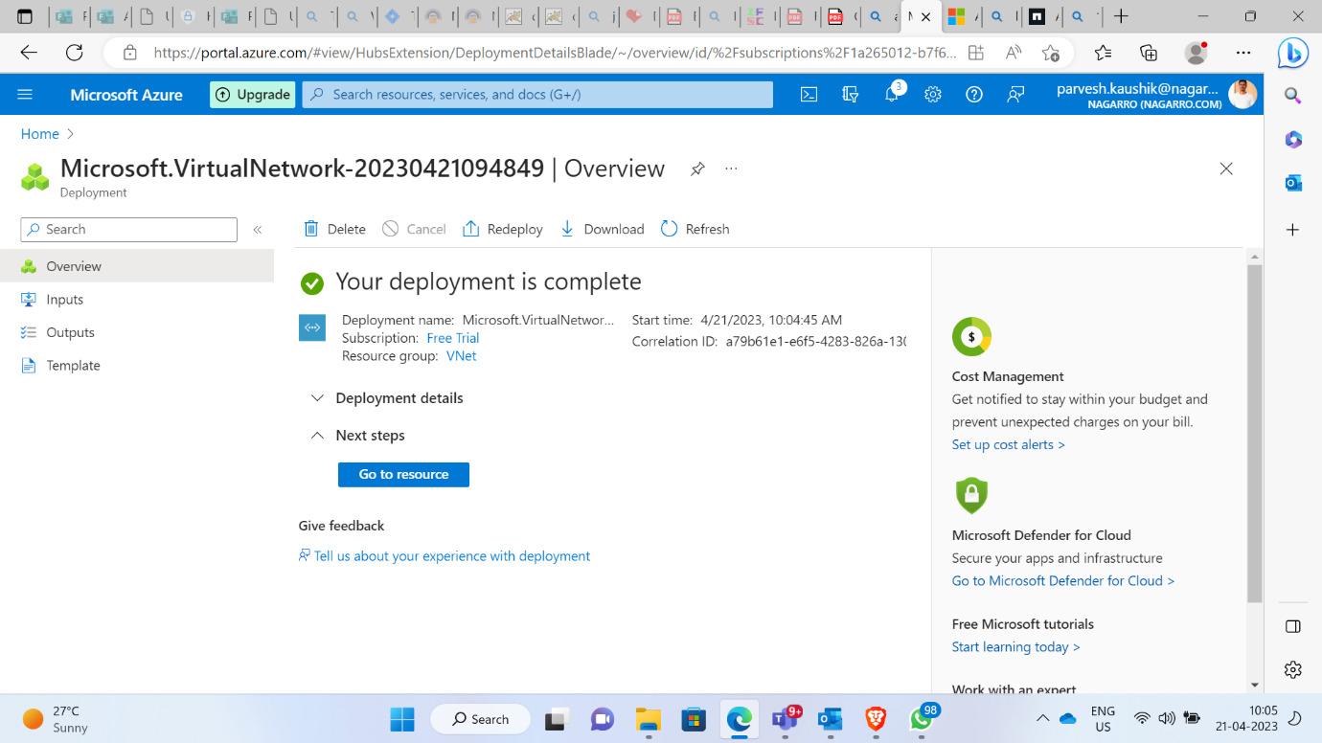

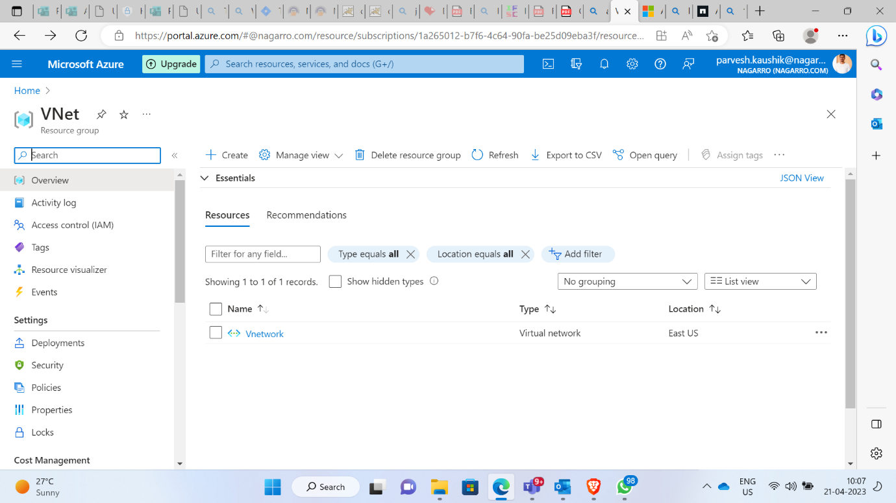

**Created a virtual network named Vnetwork in resource group vnet**.

**Vnetwork has two subnet named subnet1 and subnet2 with 16 ips.**

**Question 2: Inside one of the subnets, create a VM and deploy an application code inside it and it should leverage the database on the cloud (any existing application created by you before)**

**Solution :**

**Deploying existing app from visual studio in azure virtual machine**

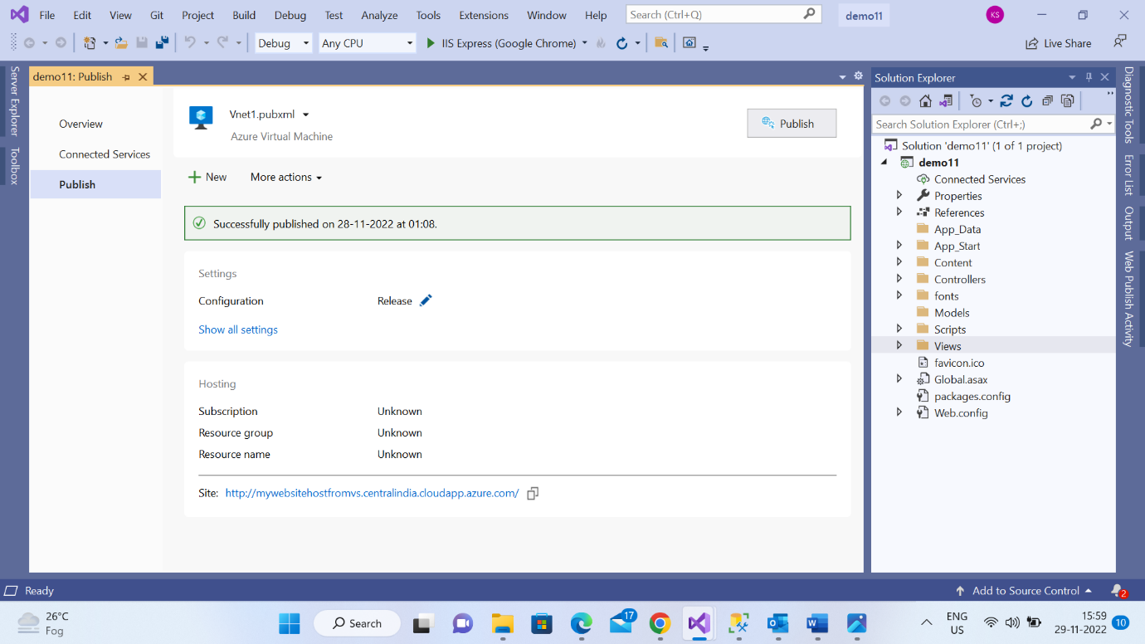

**Database creation in database server demo890**

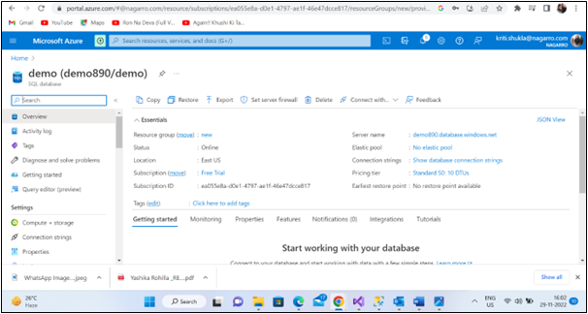

**Question 3 : Deploy the same application to Azure App Service. It should also leverage the database on the cloud.**

**Create a azure app service named AzureServiceForWeb**

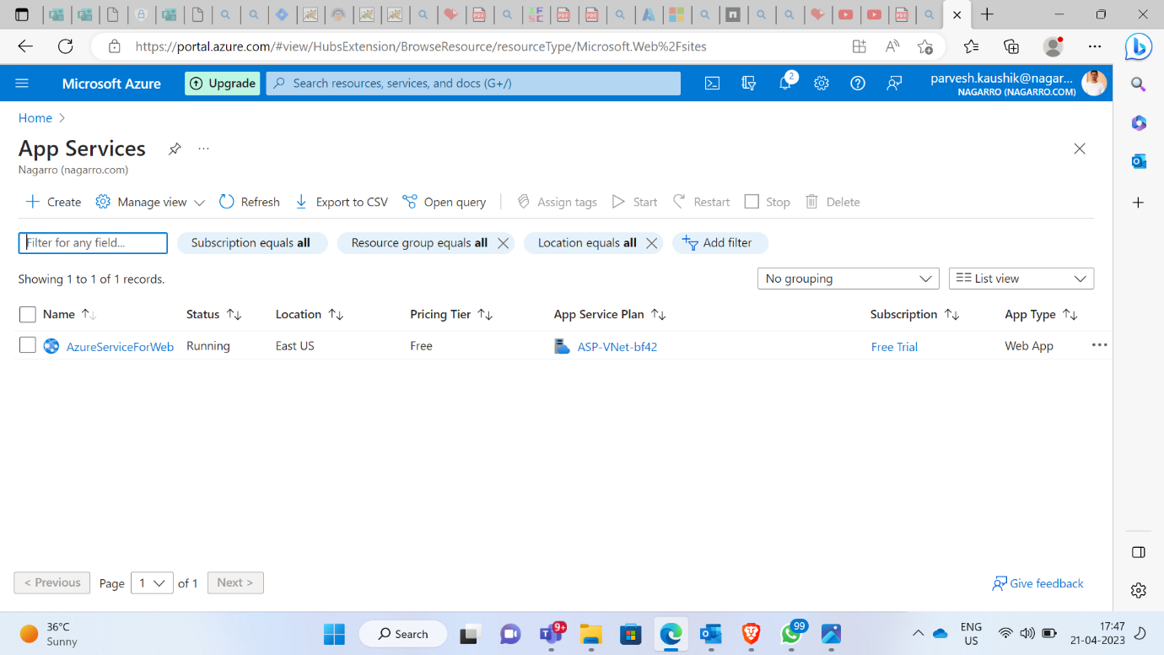

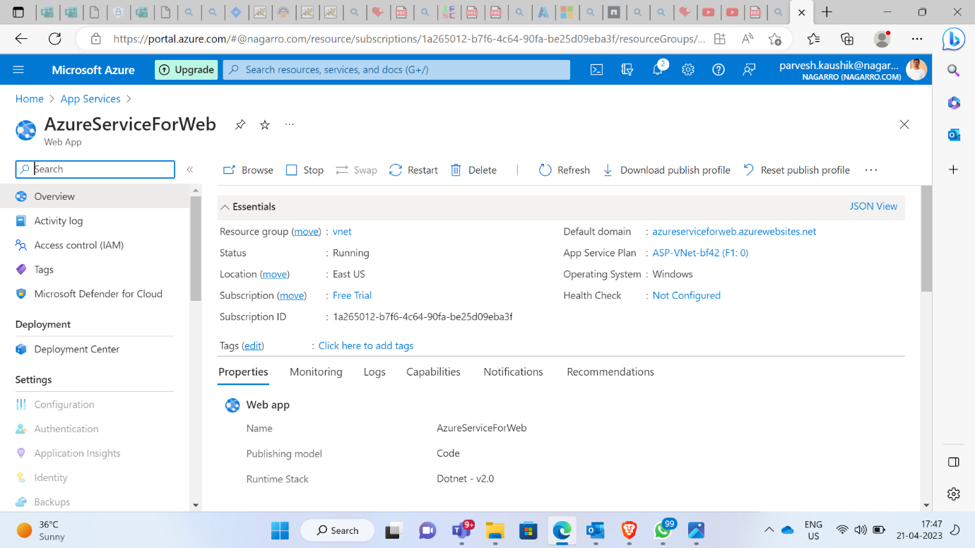

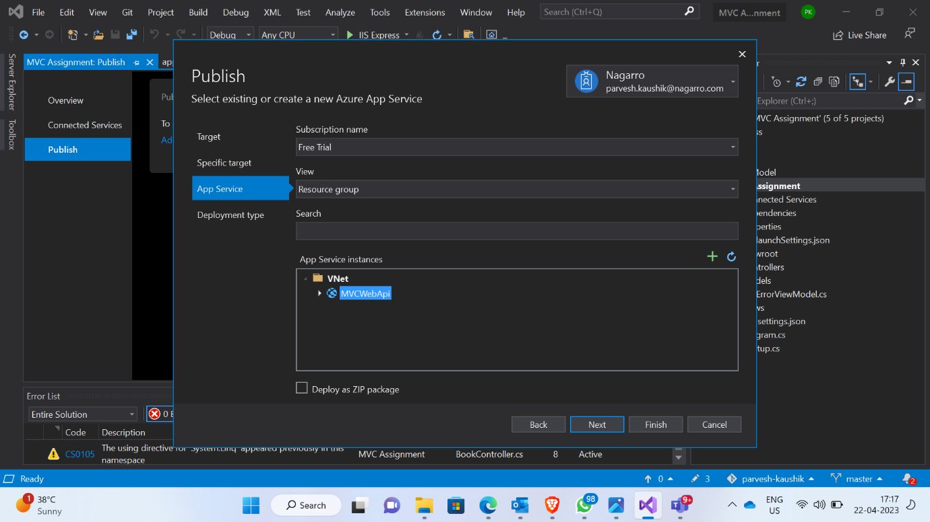

**Publishing app service in visual studio for database configuration**

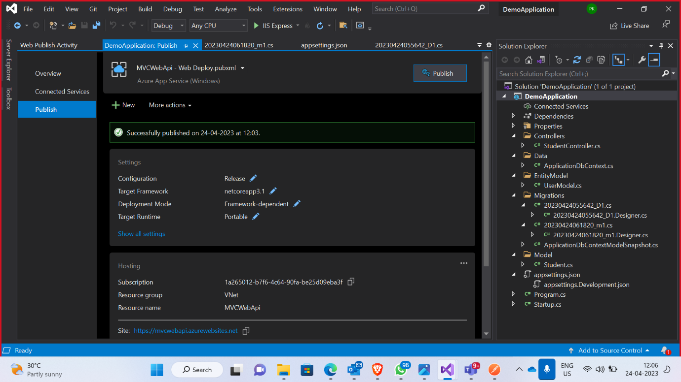

**Successfully Published**

**Question 4: Create the AKS cluster (2 nodes, smallest size VM) and deploy any two services on it. Services should be accessible from the internet.**

**Solution :**

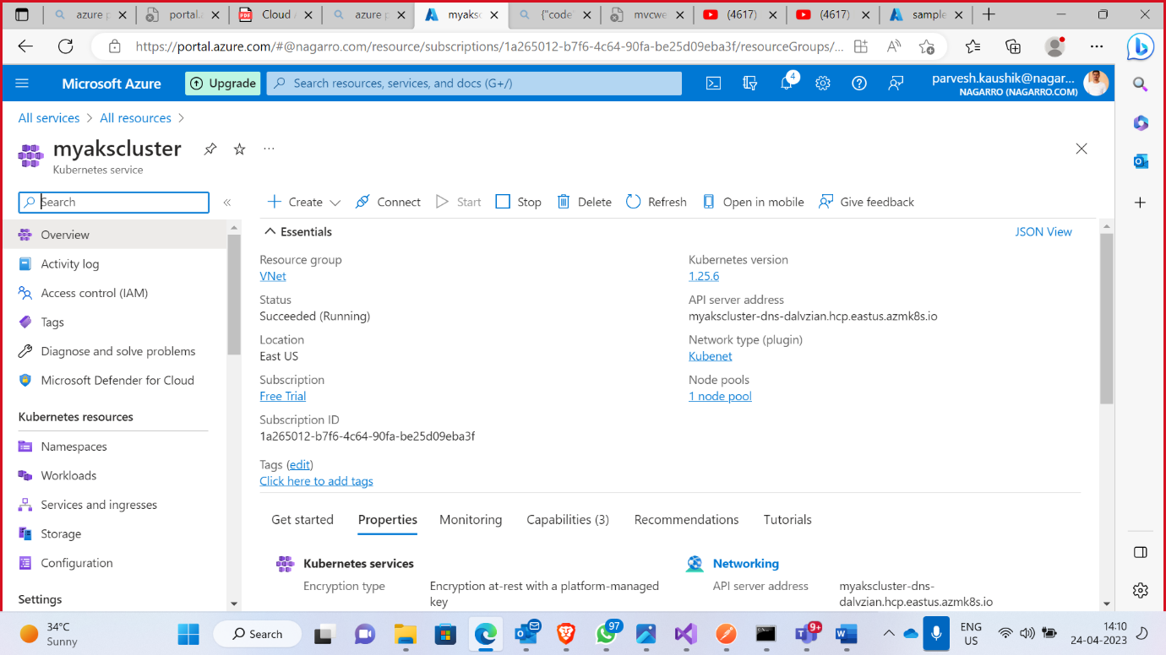

**Question 5: Create an Azure function that should trigger as soon as you upload a file in the blob storage. Function should be able to print the name of the file uploaded in the function.**

**Soluttion :**

**Create a storage account named functiontest25**

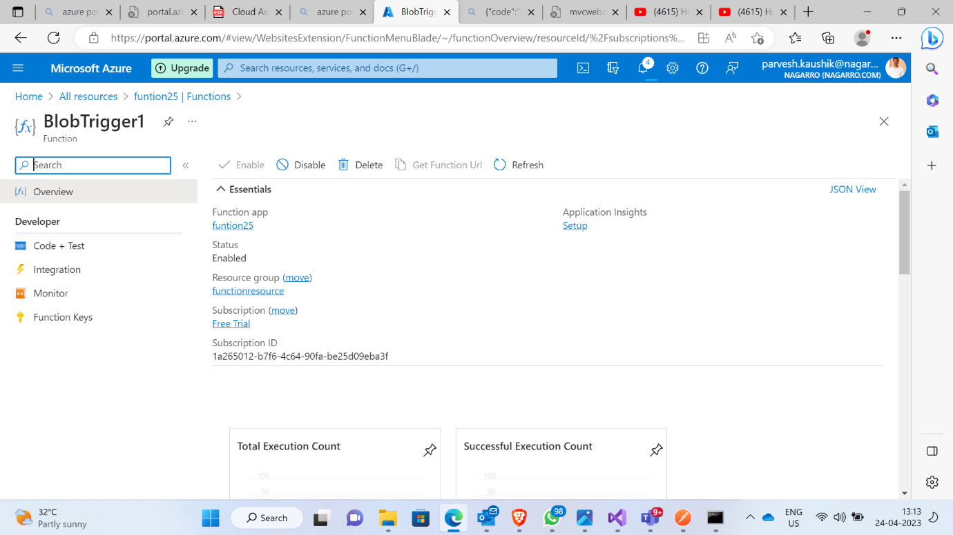

**Created a function named BlobTrigger1 to trigger**

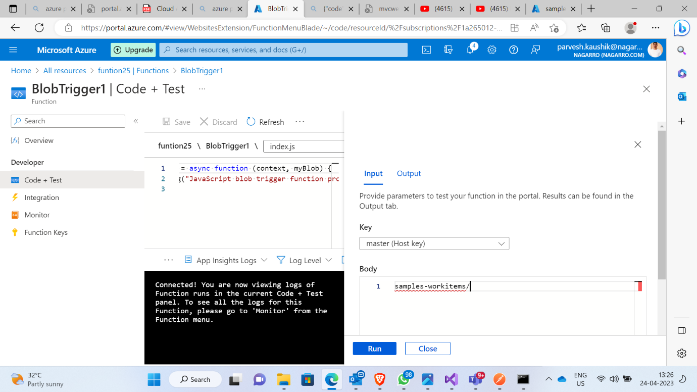

**Code to trigger the upload of a file**

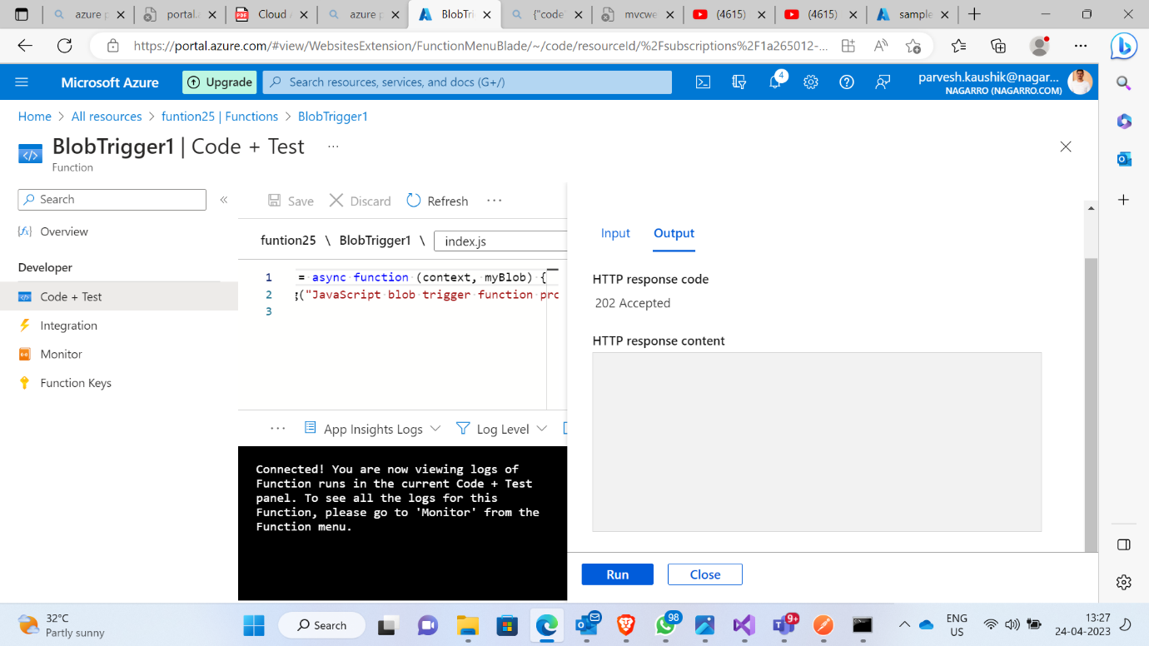

**Final trigger the file upload**